Equipment Failure Prediction – Summary Document
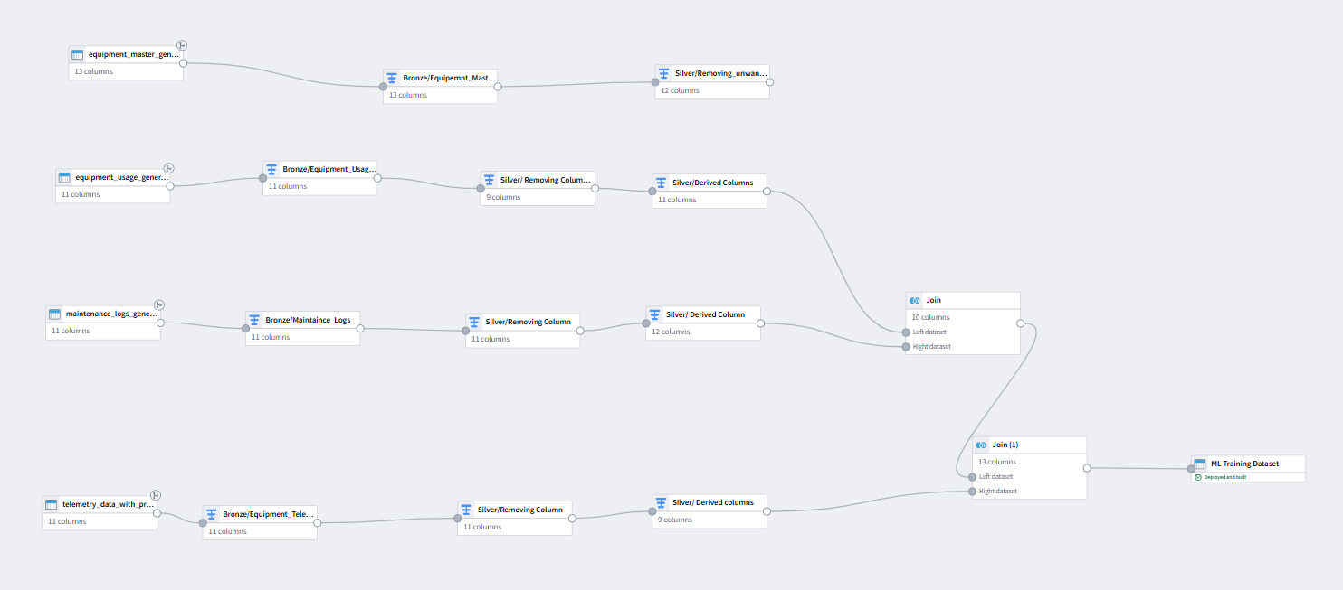

1. What the model does:
- The model predicts the probability that an equipment will fail during operation.
- It also assigns a risk category (High / Medium / Low) based on the predicted probability.
- This helps identify high‑risk equipment early and prioritize maintenance activities.

2. How equipment failure is predicted
- A Machine Learning model (Random Forest Classifier) was trained using historical equipment data.
- The model learns patterns from telemetry values, equipment usage, and maintenance behavior.
- It identifies warning signals such as high temperature, excessive vibration, poor fuel efficiency, and pressure instability, and uses them to estimate failure probability.

3. What information is used to train the model
Here are the key inputs the model uses:
Basic Identifiers (Used for tracking, not prediction)
- equipment_id
- equipment_type
- project_id
- usage_date
- shift

Target to be predicted
- Failure probability (as percentage)
- Risk classification (High / Medium / Low)

Main Features Influencing Failure
- Avg_operating_temp – Higher temperatures increase failure risk
- Avg_vibration_rms – High/unstable vibration indicates mechanical degradation
- Pressure_stablilty – Pressure fluctuations may signal internal issues
- fuel_efficiency – Poor efficiency often correlates with wear
- OEM, model, year – Helps understand behavior patterns for specific equipment types
- Usage shift – Indicates load patterns

4. How the risk category is calculated
After predicting the probability of failure:
- Risk is considered HIGH when failure probability ≥ 70%
- Risk is MEDIUM when probability is between 40% and 70%
- Risk is LOW when probability is below 40%
These thresholds help maintenance teams quickly understand urgency levels.
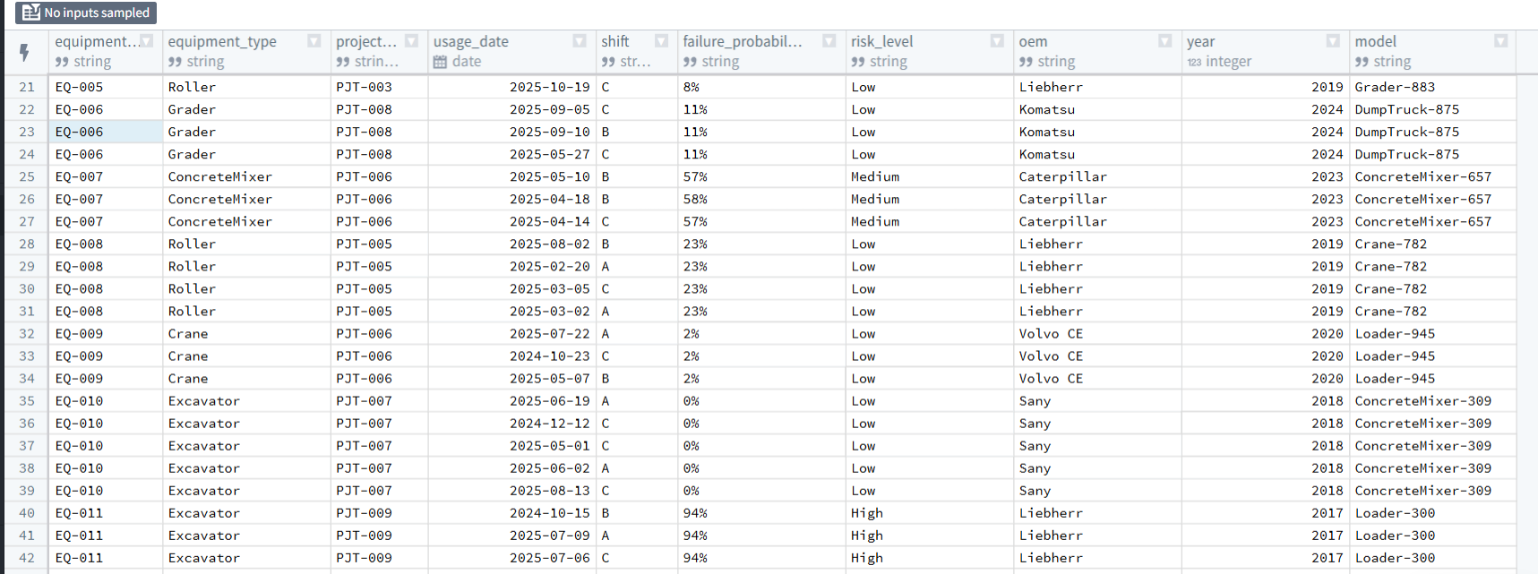

5. What the final equipment prediction table shows
For each equipment entry, the final table provides:
- equipment_id
- equipment_type
- project_id
- usage_date (in original format)
- shift
- failure_probability_percent
- risk_level
- OEM, model, year

This gives a clear and complete view of equipment health and failure likelihood.

6. How the output can be used
The predictions help maintenance and operations teams by:
- Identifying high‑risk equipment before failure occurs
- Planning preventive maintenance more effectively
- Reducing downtime and breakdown costs
- Supporting data‑driven decision‑making

